Group 6 - Automated Port Scanner
Kenneth M Davis Jr, Ryan Jay Thomas R De Los Santos, Edgar Macedo, &Martin Healey,
National University
CYB333 Security Automation
Vincent G. Chapman
June 21ST, 2026
.

Abstract
This paper will brief you on our project objective and what we achieved in developing an Automated Port Scanner in Python to assist with basic security assessments. Since we are still learning Python, we selected a project that is realistic in scope while providing an opportunity to develop programming and cybersecurity skills. The tool will allow a user to enter an approved IP address or hostname and scan a predefined list of common ports associated with services such as SSH, HTTP, HTTPS, FTP, RDP, and SMB. The scanner will identify open and closed ports, display the results, and generate a simple report that can be saved for future review.

GitHub Repository URL
https://github.com/healeymd23/CYB333-Automated-Port-Scanner

Introduction
This Automated Port Scanner is a professional Python tool designed for basic security assessments and network auditing. It efficiently maps network attack surfaces by identifying active hosts, open ports, and running services, providing cybersecurity professionals with the actionable intelligence required to harden infrastructure against potential vulnerabilities. Our project directly relates to Security Automation because it automates a repetitive task commonly performed during network assessments and vulnerability identification. Through automating port discovery, security professionals can spend more time analyzing results and investigating risks. Through this team building, our group will gain experience with Python programming, networking fundamentals, automation concepts, and cybersecurity tools while developing a practical solution that demonstrates the value of security automation.

Development Process
The project began kind of shaky; really, shaky as we didn’t even get together until the first Sunday of a deadline due that day. Not ideal. Nevertheless, with a comprehensive self-assessment, of who had what qualifications, where are gaps where and simply who wanted to volunteer for the task necessary to complete the course project. This involves comparing current competencies against a blank canvas desperately seeking aptitude for future career employment and milestones. Using the SMART(A couple of Navy Mustangs in the group) goal framework (Specific, Measurable, Achievable, Realistic, Time-bound), we established short- and long-term objectives, outlines milestones, and identified required resources and deadlines for due out’s that coincided with required meets up on discord voice so we could critique each other, while maintaining our ability to keep on schedule and delivery an on time, one shot one kill project.
Use of AI Tools
Some of the group used ChatGPT during their scripting obstacles. It provided some meaningful insight as to methods and or solutions to put through trial and error.

Project Challenges
We had a hard time getting everyone together on the same chat at the same time, discord for all of its great features, still could not manage to fully encapsulate that task. I think we learned to read the syllabus. However, we found out we had some network talent with decades of experience, and a zebra never sheds its stripes.

Reflection on Learning
Security automation reduces manual workloads and accelerates threat response times by streamlining routine incident detection, containment, and investigation. This project translated theoretical security policies into automated playbooks, optimizing efficiency and allowing teams to focus on high-level threat hunting. By integrating software-driven workflows, this initiative fundamentally shifted the approach from reactive, manual intervention to proactive, autonomous resilience. This deeper understanding highlights how automation ensures consistent threat management, scales defenses against complex infrastructure, and significantly reduces the mean time to detect and remediate vulnerabilities.
Throughout this project, the group successfully cultivated and refined several key competencies. Those of us who needed to improve our scripting and API integration were able to do so by writing numerous automation scripts and connect disparate security tools, ensuring seamless communication across the organization's technological ecosystem. Our Data framing growth allowed us to filter and rank incoming security data, ensuring automated workflows respond only to verified threats while minimizing false positives.

Time Management
I estimate as researcher and writer that we spent about 212 hours individually after discussions and as a group about 8 to 10 whether on discord or in class. The best strategy we set and executed was a meeting start and finish time. There were not any standard college students in our group, and we all have other real life responsibilities and or engagements. Thus, once individual task was divided up, we all probably mentally allocated what we believe was the right amount of time to the project phases, assuming that writing the core scanning loop will take the bulk of their schedule. In reality, basic socket connection code can be written in minutes, leading to a false sense of security. The true time sink lies in optimization, multithreading, and handling diverse network responses, which groups routinely underestimate and postpone until the final days. Once again, the good ole, Sunday college crunch time.

Video Demonstration or Screenshots showing the code successfully running.

Figure 1
Scanning Localhost IP Address Using Common Ports Option
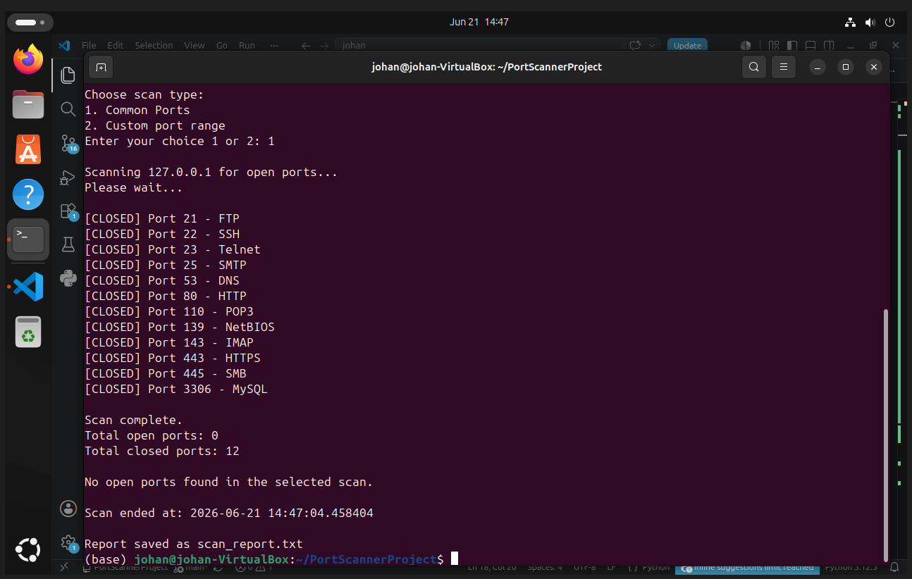
Note. Screenshot taken by author from a personal virtual machine instance running an Ubuntu environment. Script is scanning localhost using common ports list which is option 1.

Figure 2
Scanning Localhost Address Using Custom Range Option
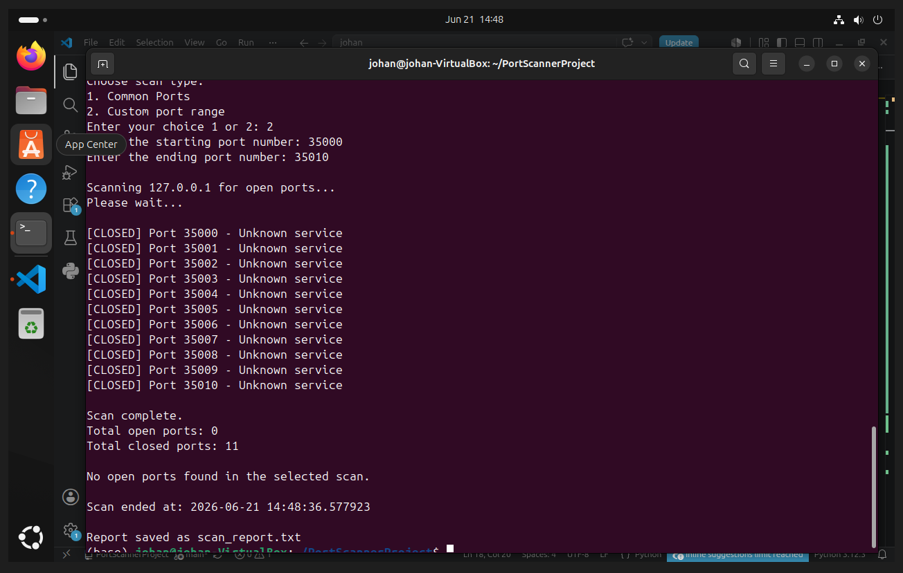
Note. Screenshot taken by author from a personal virtual machine instance running an Ubuntu environment. Script is scanning localhost ports through custom range which is option 2.

Figure 3
Scanning scanme.nmap.org Website Using Common Ports Option
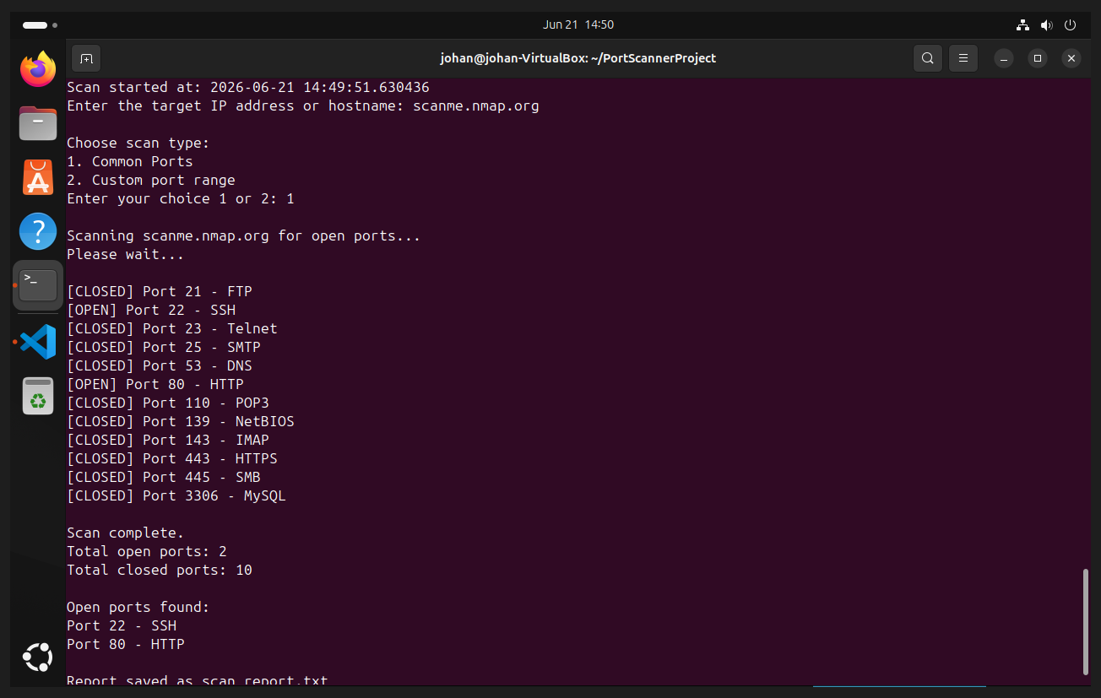
Note. Screenshot taken by author from a personal virtual machine instance running an Ubuntu environment. Script is scanning the website scanme.nmap.org for open ports using common ports list which is option 1.

Conclusion
Port scanning can be illegal or against policy if performed against systems without permission. Unauthorized scanning may violate computer fraud laws and provider terms of service. For this assignment, the individual team member responsible for this section scanned only their local machine and `scanme.nmap.org`, which is explicitly provided for scanner testing. They did not scan third-party websites or networks. They used modest delays between probes and limited port ranges on external targets. Responsible scanning means obtaining written permission, scanning only approved scope, documenting activity, and avoiding denial-of-service behavior (National Institute of Standards and Technology, 2008).
This assignment showed our group how low-level TCP connections work before higher-level protocols run on top. A port scanner is a basic building block of security automation: it helps inventory services, verify firewall rules, and supports vulnerability management workflows. The same patterns, timeouts, concurrency limits, structured logging, and strict scope control apply to production security tools. We also learned that reliable tooling depends as much on operational details as on the core networking logic. These skills connect directly to roles in system administration and security monitoring where scripted checks must be repeatable, documented, and legally defensible.

Reference

